Name: Sharvin Tagunde [srt240002]

Materials Design and Manufacturing – Homework 2

Metal Forming Simulation
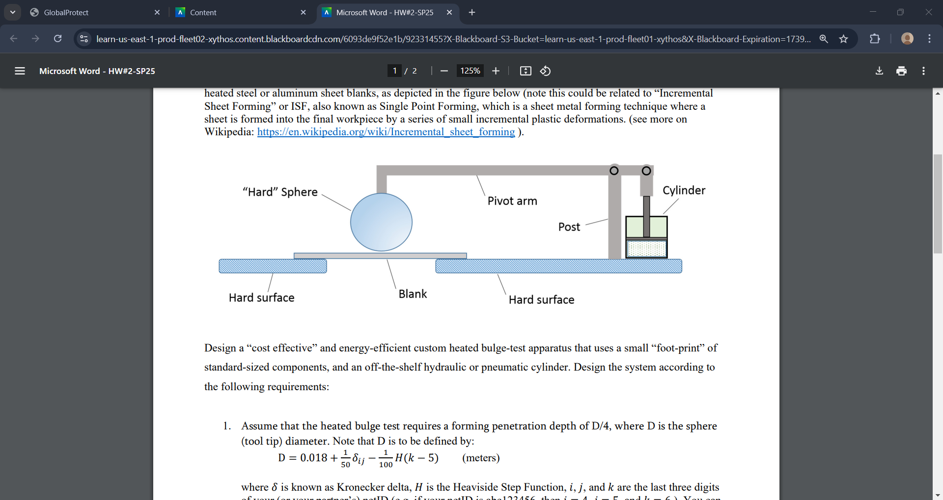
The following steps are to be performed to complete the design and analysis of bulge test apparatus following a metal forming simulation using Abaqus.
- Calculating Sphere (Tool Tip) Diameter & Forming Penetration Depth.
- Material Selection and Properties Definition.
- Metal Forming Simulation in Abaqus to model Forming operation.
- Determination of Maximum Forming Load Requirement.
- Power Computation for Heating the Blank & Metal Forming operation.
- Designing the Bulge Test Apparatus for maximum forming load.
- Assumptions, Simplifications & Conclusions.

Part 1: Design of Sphere (Tool Tip) & Forming Penetration Depth
- Calculating the Sphere Diameter and Forming Penetration Depth:
Using the equation: $D=0.018+ \frac{1}{50}δij- \frac{1}{100} H\left(k-5\right) (meters)$
- Defining the Kronecker Delta ($δ$); Taking the values, i = 0, j = 0 & k = 2:
$δ_{ij}=\left\{\begin{aligned}1, & if i=j \\ 0, &if i ≠j\end{aligned}\right.$ ; Hence $δ_{ij}= δ_{00}= 1$
- Defining the Heaviside Step Function (H):
$H(x)=\left\{\begin{aligned}1, & if x≥0 \\ 0, &if x <0\end{aligned}\right.$; Since k =2, H (k-5) = H (2-5) = H (-3).
As we are getting negative value for H (-3) we will take the value of step function as H = 0
- Now substituting the values in the equation:
$D=0.018+ \frac{1}{50}(1)- \frac{1}{100} (0)$ = 0.038
Sphere (tool tip) diameter (D) = 0.038 m; Forming Penetration Depth (D/4) = 0.0095 m

Part 2: Material Selection and Properties Definition
- For forming operations generally aluminum or steel is used. Aluminum is a better option at elevated temperatures as it requires lower forming forces. Thus, selecting the Aluminum 6061 material for our analysis as it exhibits temperature and strain rate dependent behavior.
- There are 2 different methods to define properties by inputting the true stress strain data in tabular format or by using the Johnson Cook Model which is an advanced approach as it accounts for strain rate & temperature effects.
The Johnson Cook Flow Stress equation is given as:
$$σy \left(εp, \dot{ε}, T\right)=\left[A+B{εp}^{n}\right]\left[1+Cln\left(\dot{ε}p^{*}\right)\right][1-{(\frac{T-T_{ref}}{T_{melt}- T_{ref}})}^{m}]$$
For Aluminum 6061, Youngs Modulus (E) = 68.9 × ${10}^{9}$ Pa; Poisson’s Ratio = 0.33
- Material Constants for Aluminum 6061(Johnson Cook Parameters)
Constant | Value | Parameter
A | 324 × ${10}^{6}$Pa | Yield Stress
B | 114 × ${10}^{6}$ Pa | Strain Hardening Modulus
n | 0.42 | Strain Hardening Exponent
C | 0.002 | Strain Rate Sensitivity Coefficient
m | 1.34 | Thermal Softening Exponent
T-ref | 25ᵒC (298K) | Reference Temperature
T-melt | 582ᵒC (855K) | Melting Temperature

Part 3: Metal Forming Simulation in Abaqus to model Forming operation
The simulation is performed at two different temperatures and two different average strain rates.
Temperature (K) | 473 K (Low Temperature) | 673 K (High Temperature)
Strain Rate (s⁻¹) | 10⁻³ s⁻¹ (Slow) | 10¹ s⁻¹ (Fast)

- Part Sketching and Assembly:
Using Axisymmetric sketching to create parts where only the right side of the sketch is created that will be symmetric about Y axis and assembling the created parts by defining the constraints.
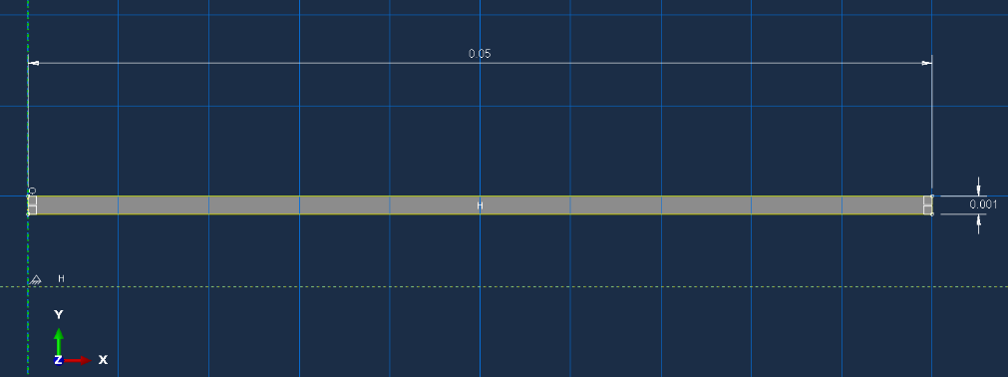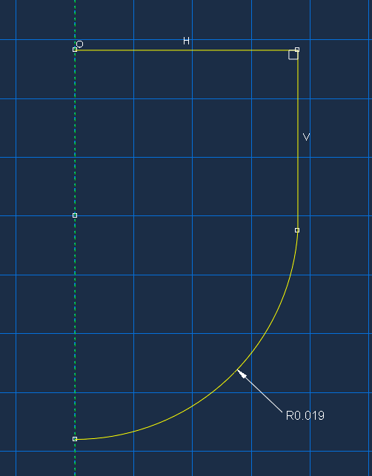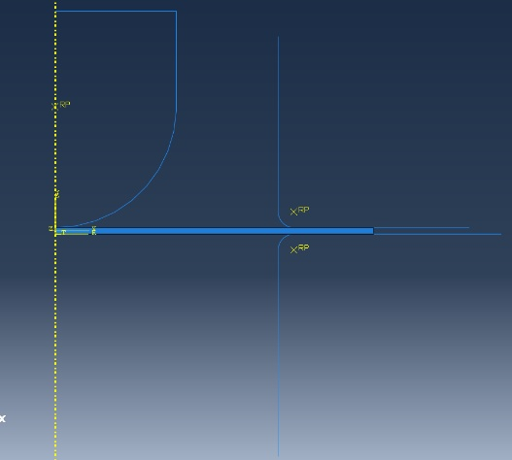
- Material Properties and Steps:
Using Johnson Cook Hardening and Rate-depending data we can input the parameters and other elastic, plastic & thermal properties of the material Aluminum 6061.
Creating 2 analysis steps involving the first step in which holder force is applied to hold the blank and then in the second analysis step the punch stroke is applied using appropriate time steps needed and the increment size. Also using the Interactions tab to apply friction and frictionless contact between the parts.

- Loading and Meshing:
Applying the Boundary conditions, we will fix the die and apply a holder force to hold the blank. The punch will move with a certain velocity in the required time step to create a max deformation U2 of 0.0095 m (from the calculations) this velocity is calculated for the required strain rate case using the formula: Strain Rate ($\dot{ε}$) = Punch Velocity (v) / Initial Blank Thickness (h); and finally the time required to complete this step by the formula: Displacement = Velocity (v) × Step Time.
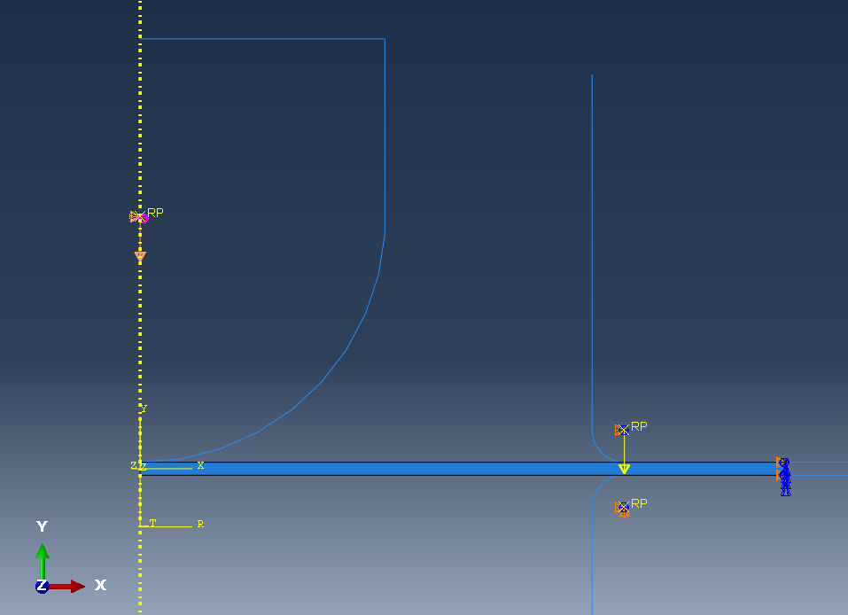
For meshing of axisymmetric parts, we will use the coupled temp displacement (CAX4T) element type which is a 4-node element.
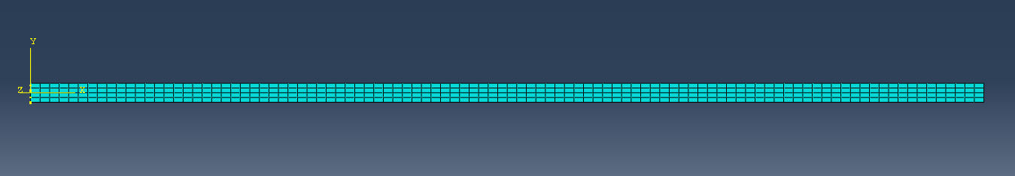

- Results:
For Case 1: Temperature: 473 K & Strain Rate: 10⁻³ s⁻¹
Stress & Deformation:
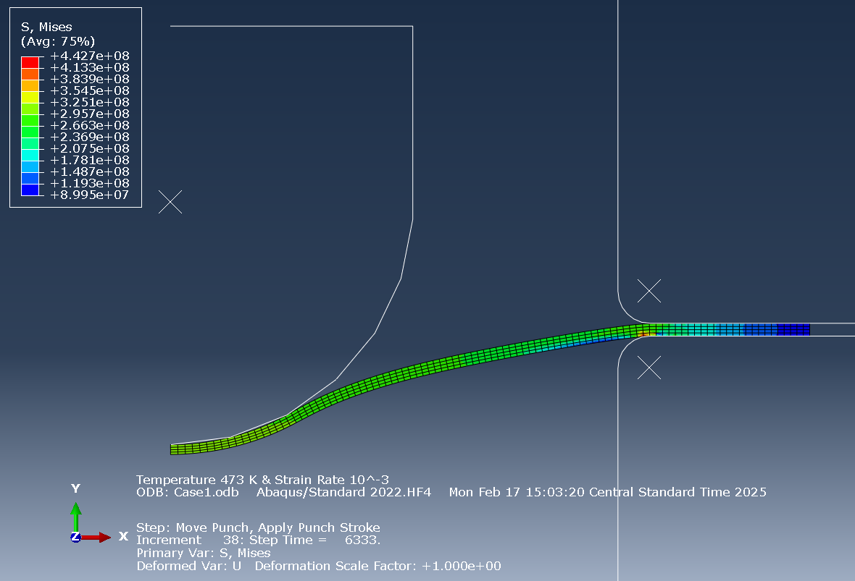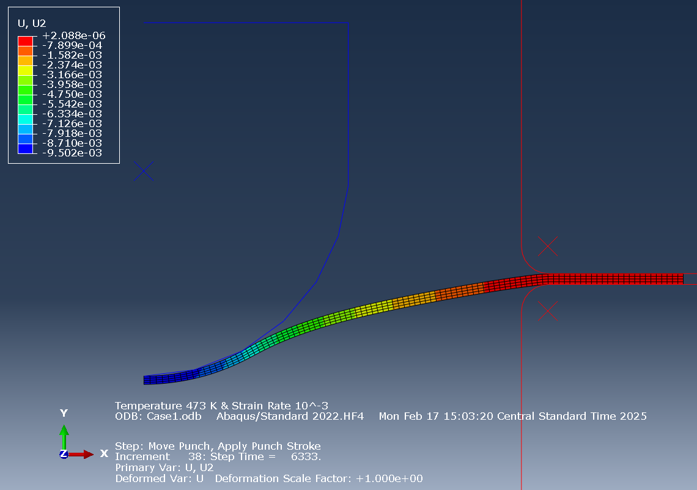
Reaction Force:
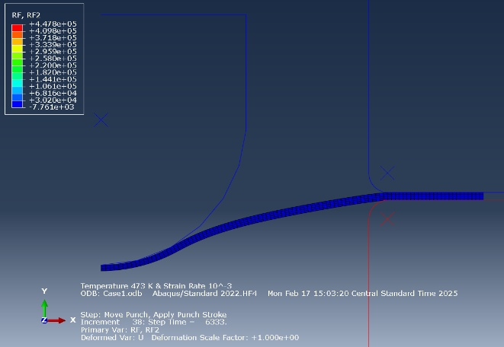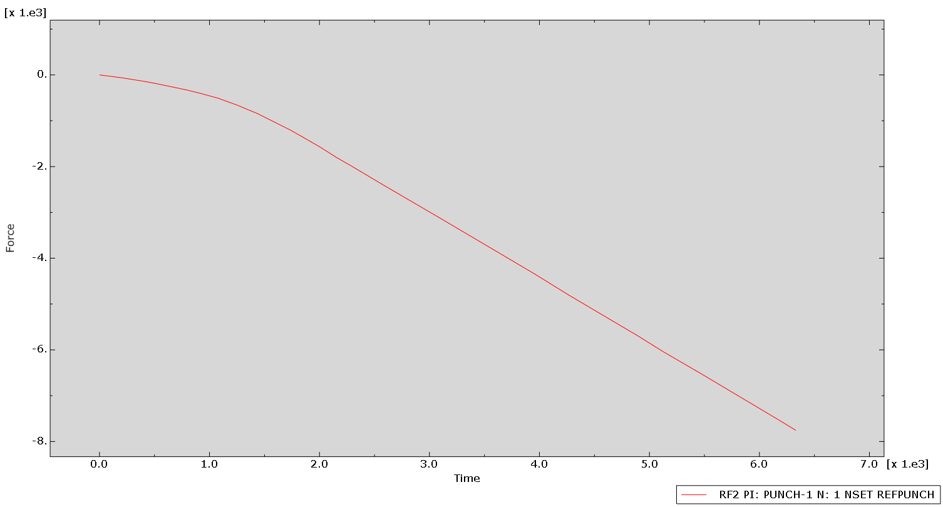
For Case 2: Temperature: 473 K & Strain Rate: 10¹ s⁻¹
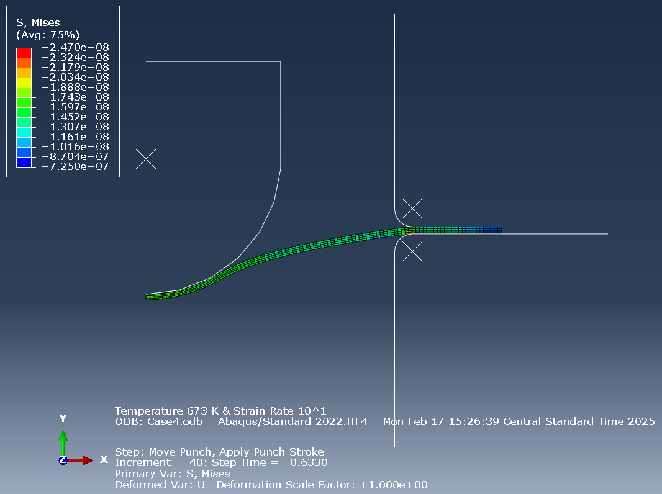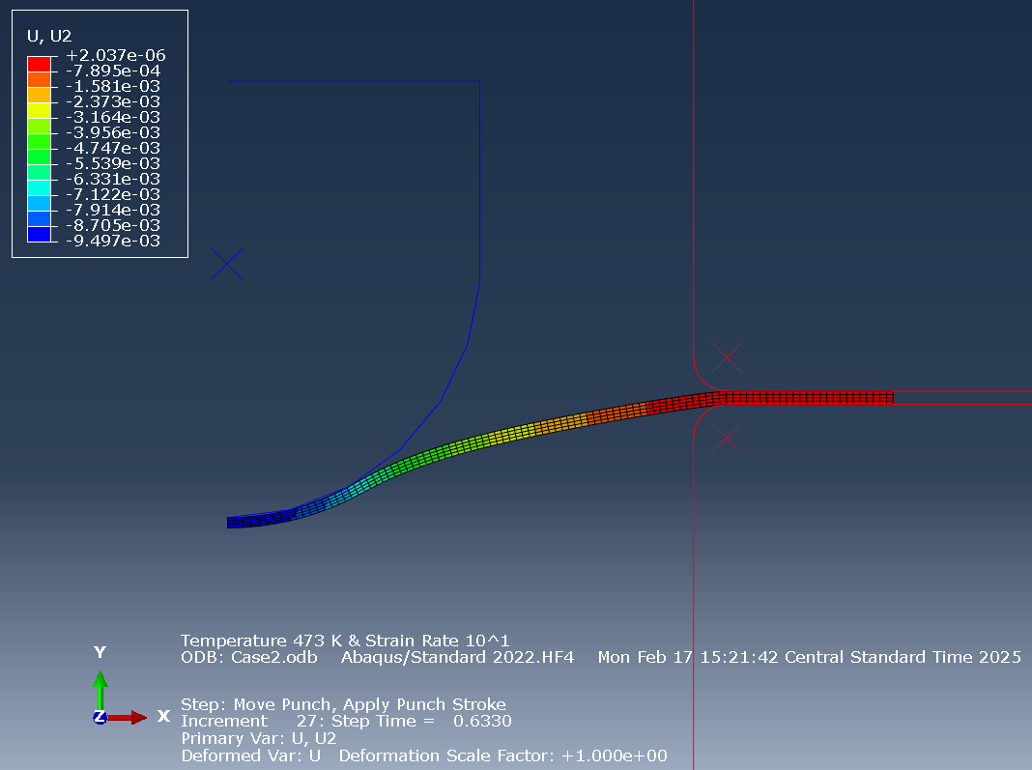
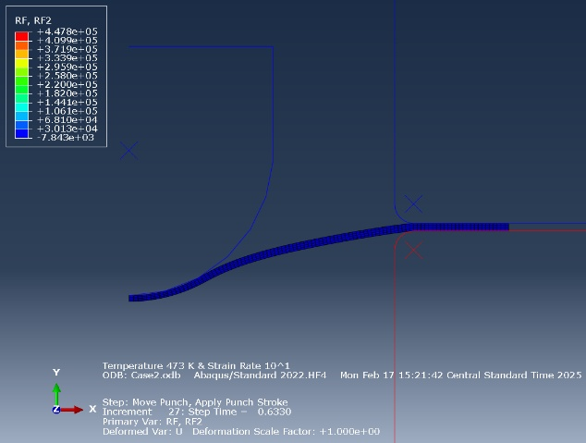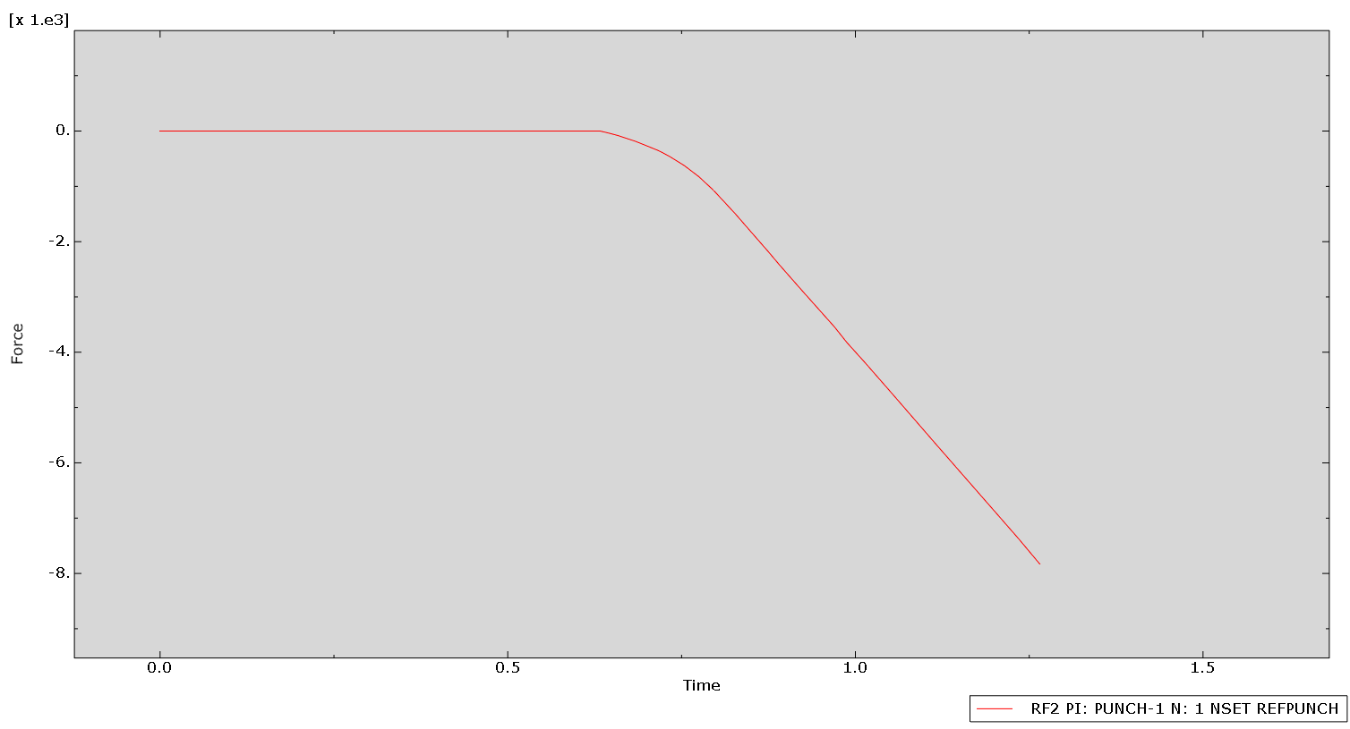
For Case 3: Temperature: 673 K & Strain Rate: 10⁻³ s⁻¹
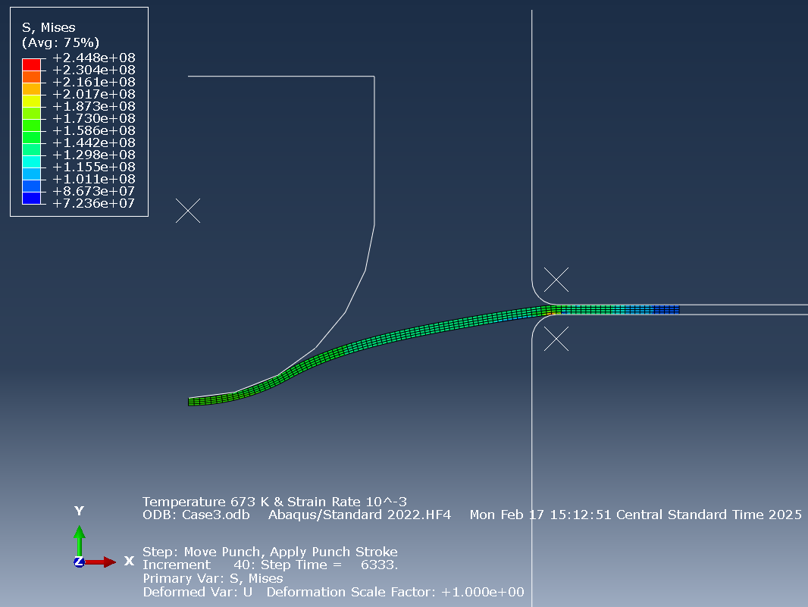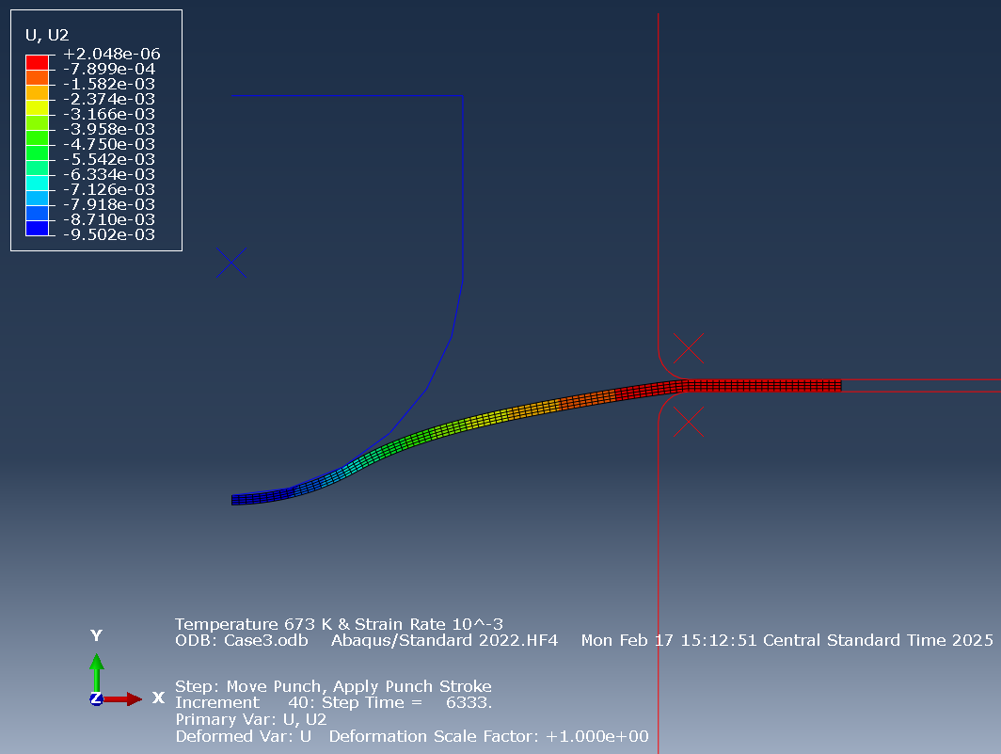
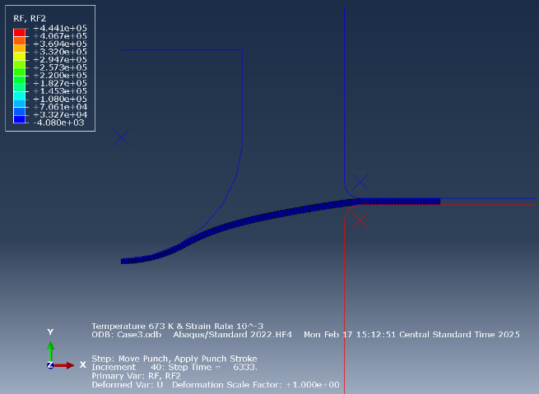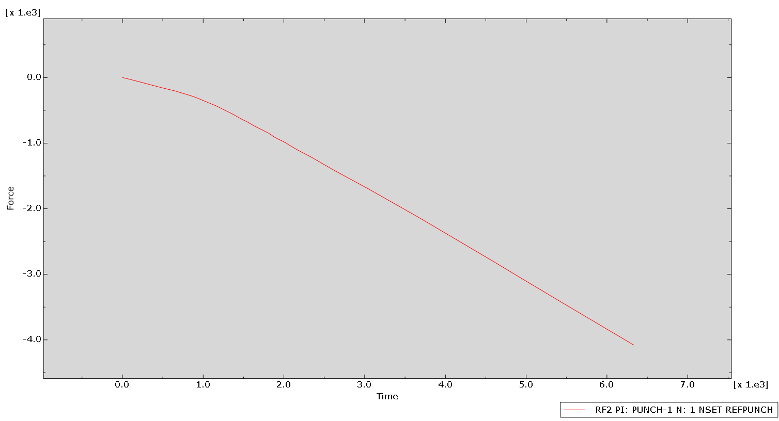
For Case 4: Temperature: 673 K & Strain Rate: 10¹ s⁻¹
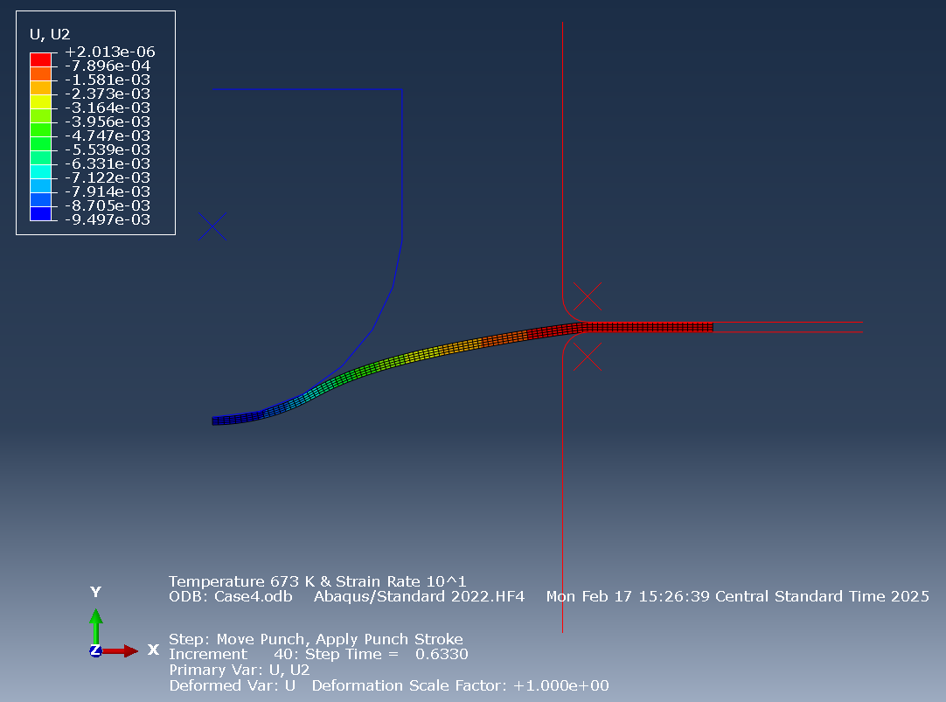
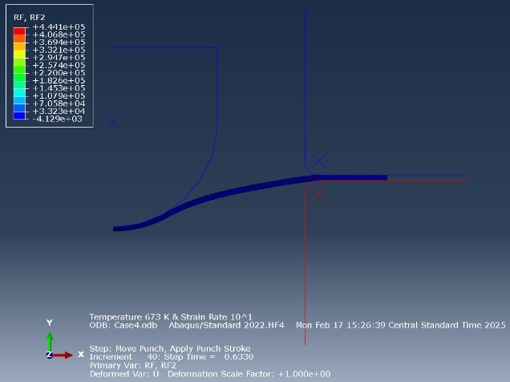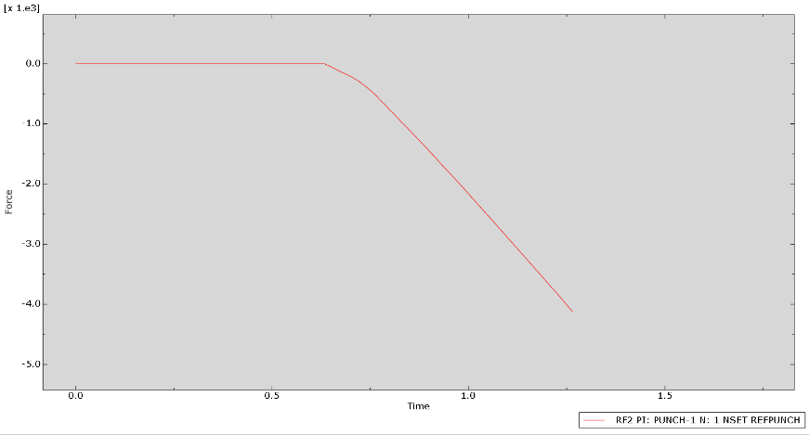

Part 4: Determining the Maximum Forming Force required for operation
The following values of reaction forces are obtained from the four conditions of simulation.
Case | Temperature (K) | Strain Rate (s⁻¹) | Maximum Reaction Force (N)
Case 1 | 473 K | 10⁻³ | 7761.41
Case 2 | 473 K | 10¹ | 7842.58
Case 3 | 673 K | 10⁻³ | 4079.74
Case 4 | 673 K | 10¹ | 4129.02

Thus, from the above results we can take the reaction force value of Case 2 as the operating force required for the forming operation. So, F = 7842.58 N or 7.85 KN.
Using this as the forming load required for further power calculation.
Part 5: Power Computation for Heating the Blank & Metal Forming Operation
Material: Aluminum 6061
Given:
- Blank Dimensions: 0.1m × 0.1m × 0.001m
- Force (F) = 7842.58 N (7.85 KN)
- Specific Heat (Cp) = 900 J/Kg. K
- Initial Temperature (T_{i})= 298 K
- Final Temperature (T_{f}) = 473 K
- Density (ρ) = 2700 kg/m³

- Power Required for Heating:
Mass of Blank (m) = Density (ρ) × Volume (V)
m = (2700) kg/ m³ × (0.1×0.1×0.001) m³
m = 0.027 kg
Heat Energy Required (Q): Q = m × Cp × ΔT
Q = 0.027 × 900 × (473 - 289)
Q = 4252.5 J
Power Required to Heat the Blank (P _{heat}): Given Time (t) = 8 min = 480 sec; Efficiency ($ɳ$) = 30% = 0.30
P _{heat} = $\frac{Q}{ɳ ×t}$ = $\frac{4252.5}{0.30 ×480}$
P _{heat} = 29.53 Watts

- Power Required for Forming Operation:
Punch Velocity (v) = Strain Rate $(\dot{ε) × }(h)$ = (10¹ s⁻¹) × (0.001m)
v = 0.01 m/s
Now, Power Required for Forming Operation (P _{forming}):
P _{forming} = Force (F) × Punch Velocity (v)
P _{forming} = 7842.58 × 0.01
P _{forming} = 78.43 Watts
The total energy that the system consumes to complete the cycle is 29.53 + 78.43 = 108 Watts
So, the Power required for heating the blank from 298 K to 473 K is 29.53 Watts and the total power required for the operation is 78.43 Watts.

Part 6: Design of Bulge Test Apparatus for Forming Operation
The apparatus consists of the following key components:
- Hydraulic Cylinder
- Pivot Arm
- Punch
- Frame/Post
- Base & Fixtures

- Hydraulic Cylinder Selection:
To apply the required force, a hydraulic cylinder is to be considered as it provides higher force at low speeds and hence is very useful for forming operations. The force applied by the hydraulic cylinder is given by F = PA. Thus, by using a standard cylinder that can impart appropriate pressure, the required force can be generated.
The following dimensions for the hydraulic cylinder are to be selected:
- Bore Diameter (d) = 75 mm
- Cylinder Piston Area (A) = 4.42 × 10⁻³ m²
- Required Pressure (P) = 3.5 MPa
- Piston Stroke Length = 0.01m (to ensure full punch depth of 0.095m)

- Designing the Pivot Arm:
The pivot arm transfers force from the hydraulic cylinder to the punch.
As the pivot arm works like a lever, we can use the force balance equation to design.
AISI 1020 Steel is used for the Pivot arm with a rectangular cross section beam for strength.
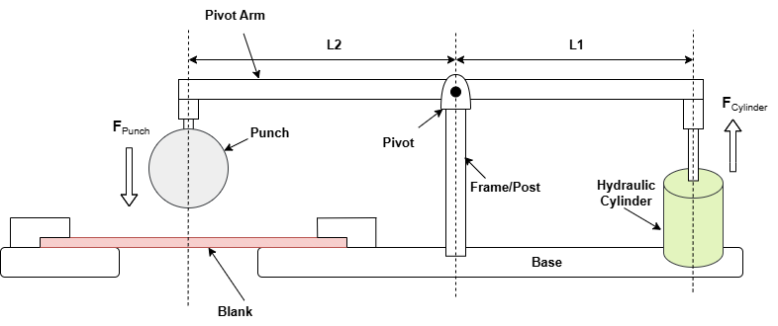
Force Balance Equation:
$$F cylinder ×L1=F punch ×L2$$
- F _{cylinder} = Force provided by hydraulic cylinder.
- L₁ = Cylinder Attachment distance from the pivot.
- F _{punch} = Force provided by punch.
- L₂ = Punch Attachment distance from the pivot.

For balanced force distribution deciding the length of the Pivot arm.
L₁ = 0.09m, L₂ = 0.05m
Now using the force balance equation: $F cylinder=\frac{7.85 ×0.09}{0.05}=14.13 KN$. Hence the hydraulic cylinder must provide a force of at least 14.13 KN to complete the forming operation.
Since $P=\frac{F}{A}$, the required pressure is calculated to be 3.19 MPa which is less than our selected cylinder pressure so we can go forward with these calculations and selections.
Dimensioned Drawing of the Bulge Test Apparatus Parts & Assembly:
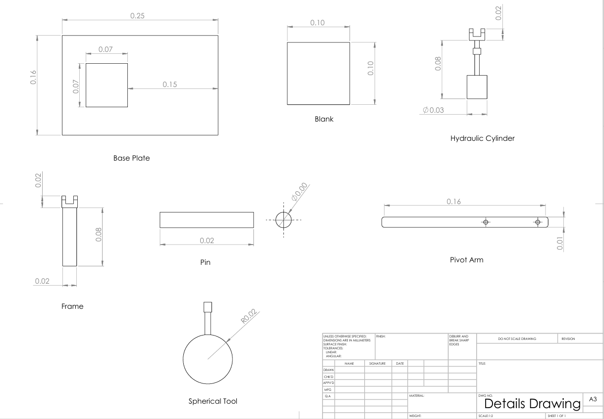
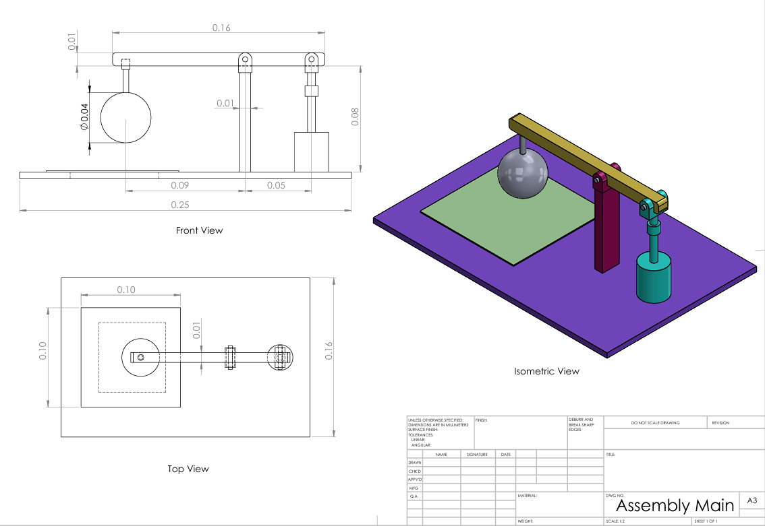
Part 7: Comments
- Assumptions & Simplifications in Desing and Analysis:
- Material used for blank (Aluminum 6061) was assumed isotropic & uniform
- Constant coefficient of friction (0.1) was used in contact interactions neglecting real world variations.
- Punch, Die and holder were considered analytical rigid assuming no deformation under loads.
- Blank was assumed to heat uniformly neglecting the thermal gradients.
- Constant material properties across the temperature range were assumed such as thermal conductivity.
- Sharp corners or stress concentrations in die and punch were ignored.

- Selection of Temperature and Strain Rate:
- The temperatures were selected below recrystallization temperature to maintain work hardening properties of the material.
- Strain rates were selected such that they differ by order of magnitude to observe the strain hardening effects.
- The expected results were such that at higher temperatures reaction forces were reduced due to thermal softening. Also, more reaction force was expected for lower strain rates due to reduced strain rate hardening effect. Hence, Maximum reaction force occurred at 473 K and 10¹s⁻¹ where strain rate hardening was most significant.

- Material Properties:
- The blank material was assumed to be isotropic. But sheet metals often exhibit anisotropy due to rolling process during manufacturing where gain structures align in a preferred direction.
- For this study, isotropic material behavior was sufficient as anisotropy mostly effects forming operations that involve significant sheet stretching rather than localized deformation.
- In this study, the dominant deformation is localized so anisotropy has limited impact.

- Fracture Prediction in the Abaqus Simulation:
- The simulation did not include failure criteria like damage models or ductile fracture models to avoid unnecessary complexity in the simulation. Without the fracture prediction, simulation could not determine the exact failure limit of the blank.
- However, stress and strain results can be used to estimate whether failure is likely based on the input material limits.

- Observations from Simulation & Design:
- Higher temperature led to lower reaction forces confirming the thermal softening effect. Also, increasing the strain rate increased resistance displaying the strain rate hardening.
- The final values for reaction forces aligned with the theoretical values which validated the simulation setup, and the results obtained.
- Johnson Cook parameters help define crucial material properties and behavior for accurate dynamic simulation analysis and the step time adjustments were crucial to avoid errors in the analysis.

- Conclusion:
The study successfully simulated bulge test operation using Abaqus, providing insights into material deformation, system design requirements and forming forces associated. The study confirmed the following aspects:
- Temperature softens material reducing reaction forces.
- Strain rate hardening increases material resistance to deformation.
- Selected hydraulic cylinder and structural components meet the required load conditions.
- The forming power calculations confirm the systems feasibility for industrial applications.

